Strengths of Materials

Chapter 2 Homework Problems

Problem 2.1

An air conditioning unit is supported with 4 rubber supports in order to control vibrations. Before loading, the rubber supports are 3 cm tall (h), 10 cm wide and 10 cm deep. The weight of the air conditioner reduces the height of the supports to 2.85 cm, while a pushing force moves the whole unit .07 mm to the right. Based on this information, determine the axial and shearing strains in the supports.

(Solution: $ϵ= -.05, γ=.0023$)

Problem 2.2

Rigid platform AB is supported by non-rigid legs AC and BD. If we measure a strain of -450 µ in leg AC, what would the strain need to be in leg BD for the platform to remain level?

(Hint: the deformations will need to be equal for the platform to remain level)

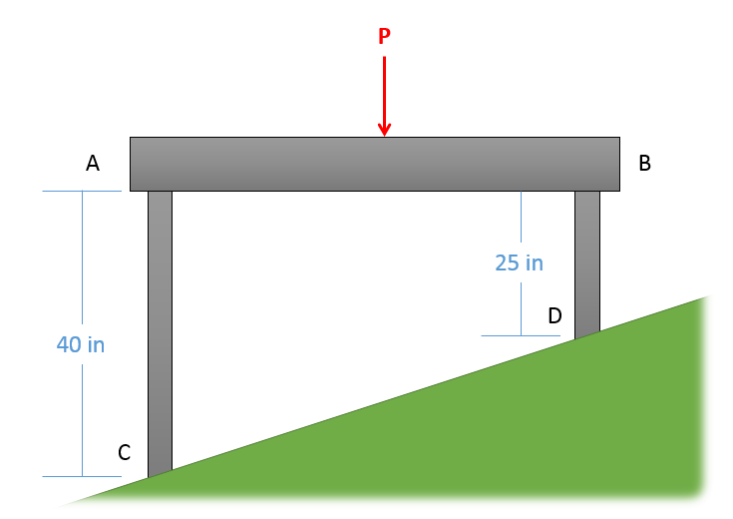

(Solution: $ϵ_{BD}= -720 μ$)